Apache Flume Installation
Process on Single-Node Cluster

Prerequisite
- JDK 1.6 or later version of Java installed on your Ubuntu/CentOS machine
- Memory – sufficient memory for configuration used by sources, channels or sinks
- Disk Space – Sufficient disk space for configurations used by channels or sinks
- Directory Permissions - Read/Write permissions for directories used by agent (/user/flume/tweets)

(Murali-note: Flume s/w is installed in /usr/lib/flume/)

Apache Flume Installation on CentOS:

- Download apache flume binary distribution from apache download mirrors at http://flume.apache.org/download.html . At the time of this installation, (apache-flume-1.5.2-bin.tar.gz) is the latest version.
- Copy the (apache-flume-1.5.2-bin.tar.gz) from Node1_SharedPath to our preferred flume installation directory, /usr/lib/flume and un-pack the tarball.

Commands are:
[hduser@localhost ~]$ sudo mkdir /usr/lib/flume
Password:hduser
[hduser@localhost ~]$
[hduser@localhost ~]$ sudo chmod -R 777 /usr/lib/flume
[hduser@localhost ~]$ cd /mnt/hgfs/Node1_SharedPath //already downloaded into this folder
[hduser@localhost ~]$
[hduser@localhost Node2_SharedPath]$ cp apache-flume-1.5.2.1-bin.tar.gz /usr/lib/flume
[hduser@localhost Node2_SharedPath]$ cd /usr/lib/flume
[hduser@localhost flume]$ tar -xzvf apache-flume-1.5.2.1-bin.tar.gz //un-pack the tarball
[hduser@localhost flume]$ ls
[hduser@localhost flume]$

- Set FLUME_HOME, FLUME_CONF_DIR environment variables in ~/.bashrc file as shown below and add the Flume bin directory to PATH environment variable

[hduser@localhost flume]$ cd
[hduser@localhost flume]$ pwd
/home/hduser/
[hduser@localhost ~]$ gedit ~/.bashrc

## Flume Home Directory
export FLUME_HOME=/usr/lib/flume/apache-flume-1.5.2-bin
export FLUME_CONF_DIR=$FLUME_HOME/conf
export FLUME_CLASSPATH=$FLUME_CONF_DIR

export PATH=$PATH:$FLUME_HOME/bin

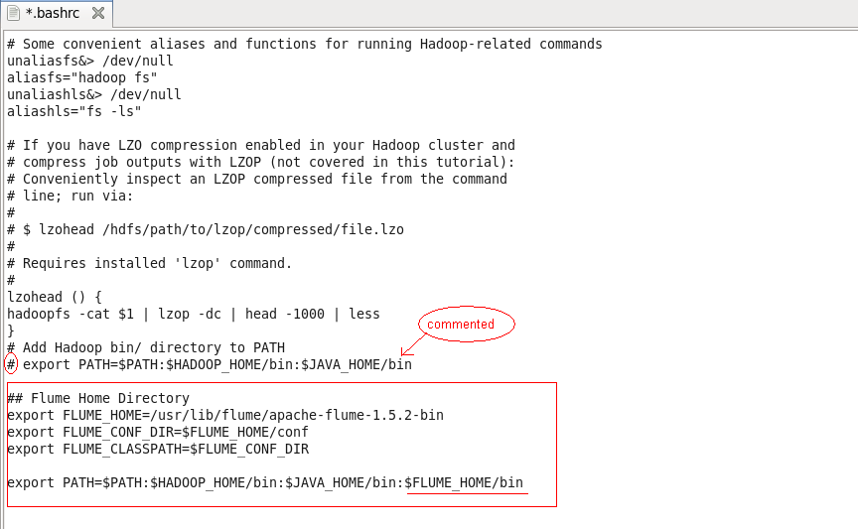

Save and close the file and execute the file as below

[hduser@localhost ~]$ source .bashrc //(or) close the terminal and reopen

- In FLUME_CONF_DIR directory, rename flume-env.sh.template file to flume-env.sh and provide value for JAVA_HOME environment variable (/usr/java/latest) with Java installation directory
- If we are going to use memory channels while setting flume agents, it is preferable to increase the memory limits in JAVA_OPTS variable. By default, the minimum and maximum memory values are 100 MB respectively (Xms 100m –Xmx200m). Better to increase these limits to 500 MB and 1000 MB respectively as shown below

[hduser@localhost conf]$ cp flume-env.sh.template flume-env.sh
[hduser@localhost conf]$ gedit flume-env.sh

## Enviroment variable can be set here.
JAVA_HOME=/usr/java/latest ##(murali-note: please give Java location of your system)

## Give Flume more memory and pre-allocate, enable remote monitoring via JMX
JAVA_OPTS=”-Xms500m –Xmx1000m –Dcom.sun.management.jmxremote”

## Note that the Flume conf directory is always included in the Classpath
#FLUME_CLASSPATH=” ”

Verify Apache Flume Installation:
We can verify the flume installation with $flume-ng --help command on terminal. If we get output similar to below then flume installation is successful.

[hduser@localhost flume]$ flume-ng --help
/-----fsdfdjfskdff--/
Note that if <conf> directory is specified, then it is always included first in the classpath..
/-------sdfsdfaf------/

With these settings, we can consider flume installation is completed…………..
++++++++++++++++++++++++++++++++++++++++++++++++++++++++++++++++++++++++++++++++

Additional Info:
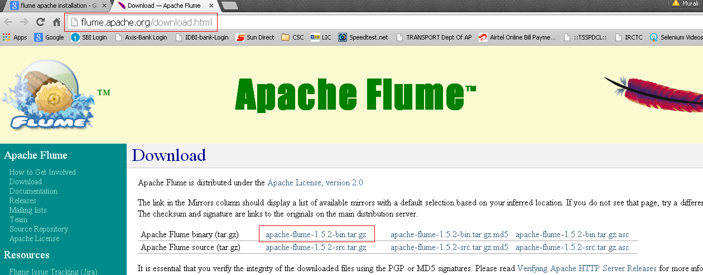
Download tar file from this site and save in D:\Node1\Node1_SharedPath

++++++++++++++++++++++++++++++++++++++++++++++++++++++++++++++++++++++++++++++++

References:
http://hadooptutorial.info/apache-flume-installation/
http://flume.apache.org/download.html

